After performing a profile audit, it was noticed that your Interfolio Faculty Profile was missing your profile picture. It is important for all faculty to have a profile picture on the outward-facing profile (https://profiles.unthsc.edu). Below are the steps needed to update your profile picture:
- Plan to have a picture taken at a scheduled "Heads Up Day" event offered by the HSC Marketing & Communications Office.
Click here to register: https://calendly.com/unthscphotos/heads-up-day?month=2023-03&date=2023-03-21
- Once you receive your picture, usually in five business days, save the picture in a location to upload. Log in to Interfolio and click on profile
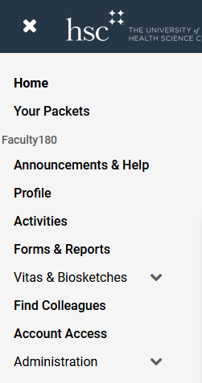

- Once you click on profile, then click on the Personal Information section

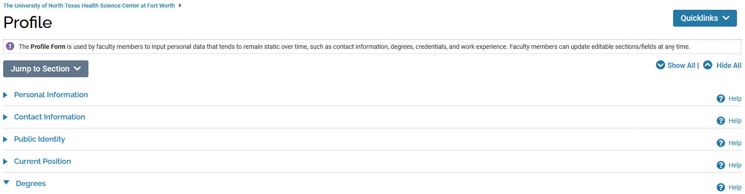

Click edit and the plus to add a picture. Upload the picture from saved location.



Email HSCInterfolio@unthsc.edu with any questions you may have.

